**Chitral:**

Tirich Mir

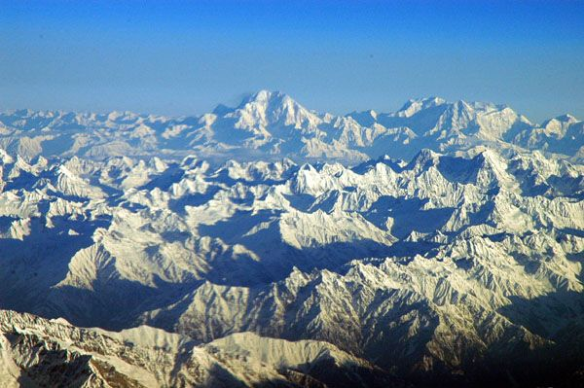

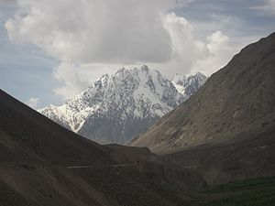

**Tirich Mir** (alternatively **Terich Mir**, **Terichmir** and **Turch Mir**) is the highest mountain of the Hindu Kush range, and the highest mountain in the world outside of the Himalayas Karakoram range, located in Chitral District of Pakistan. The mountain was first climbed on 21 July 1950 by a Norwegian expedition consisting of Arne Næss, P. Kvernberg, H. Berg, and Tony Streather. Tirich Mir overlooks Chitral town, and can be easily seen from the main bazaar.